* **After the tutorial’s final changes, rerun your application as shown below, with your HelloWorld controller and your Welcome method, but instead use your name and the number 2.**
  + **Sample Results:**

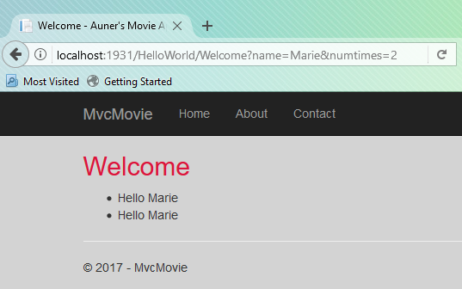

* 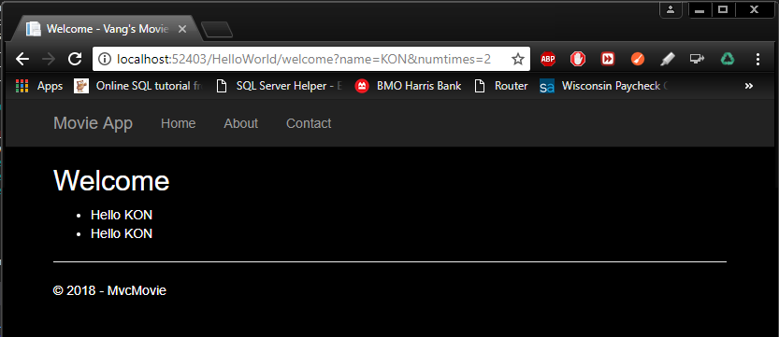**10 points: Copy/Paste your results below after using your name and the number 2 as the parameters, making sure the entire URL is readable, as shown above.**
* This ends **Part 1** of the assignment - the “**Adding a View**” tutorial.
* Continue with **Part 2** of this assignment

**Part 2: 50 points total**

* Start a new MVC project – C# / Web / ASP.NET Core Web Application (.NET Core) / Web - Name it “YourNameWausau”.
* Change Views / Shared / _Layout.cshtml
  + Change the ViewBag.Title and the first Action Link name to “Wausau City Site – Your Name”
  + 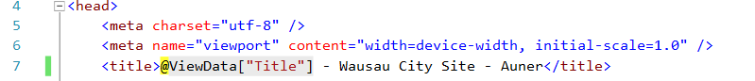
  + **3 points -** Add 3 other links - the last parameter should be “Wausau”
    - Index
    - ThingsToDo
    - AreaHotels
* 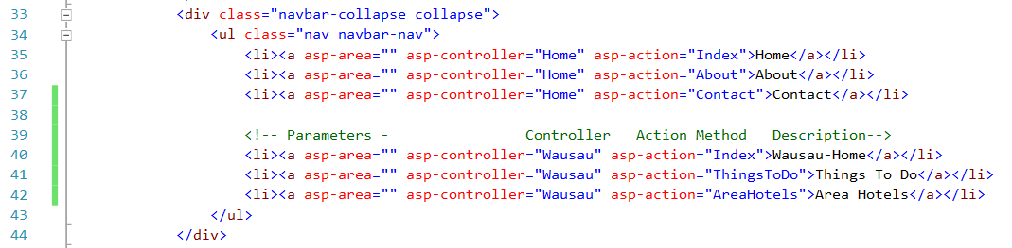Add new empty MVC Controller – Name it **WausauController**
  + Select Add Controller / Select Full Dependencies / Click Add
  + Select Add Controller again / Select Controller / MVC Controller – Empty / Name it Wausau Controller / Click Add
  + Leave the Index default action method
  + Add 2 action methods other than Index, both returning a View
    - **ThingsToDo**
    - **AreaHotels**
* Add a new **Wausau** view folder under Views
  + 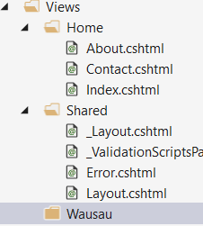
* Add 3 new **Views**: **Index, ThingsToDo and AreaHotels** – one for each action method under the new Wausau views folder
  + Use the following settings: **Add / Add New Item / MVC View Page**
  + 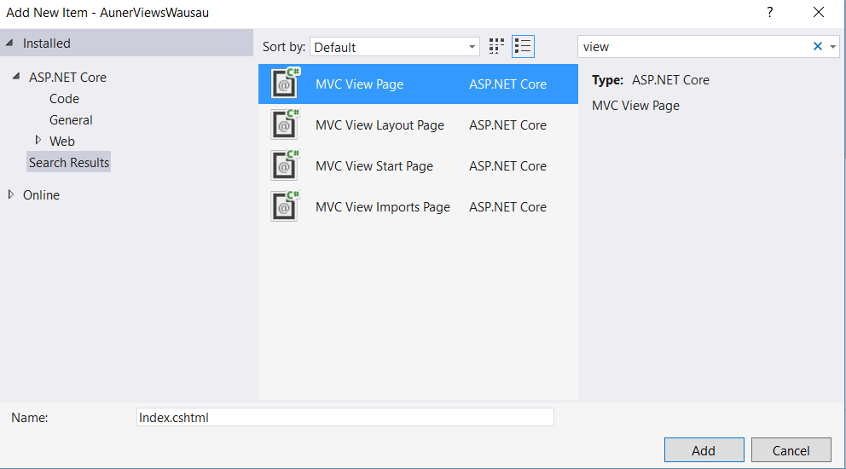
* Locate your project’s “**images**” folder (wwwroot/images)
  + Add 3 images for each page (Wausau – Index, Things to Do and Area Hotels)
    - Site your image sources on each web page
    - Make sure you add the “Alternative Text” on each image, so you are ADA compliant
* Modify your new views. Here’s some sample code you may use for reference:
  + Change the design as you wish, but keep in mind proper HTML/CSS UX design principles

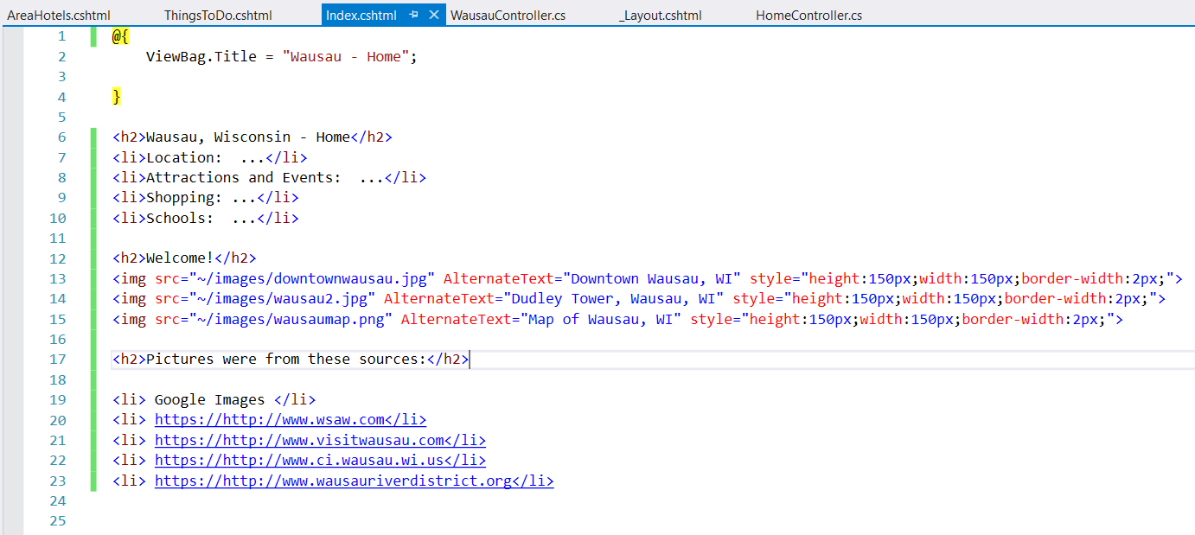

* **Sample Results**: (before any further design changes)

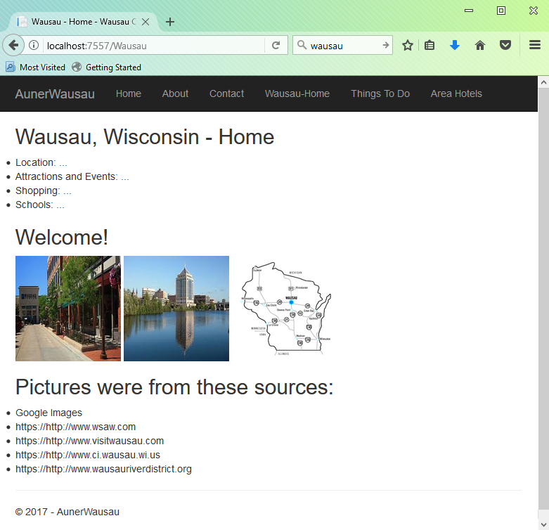 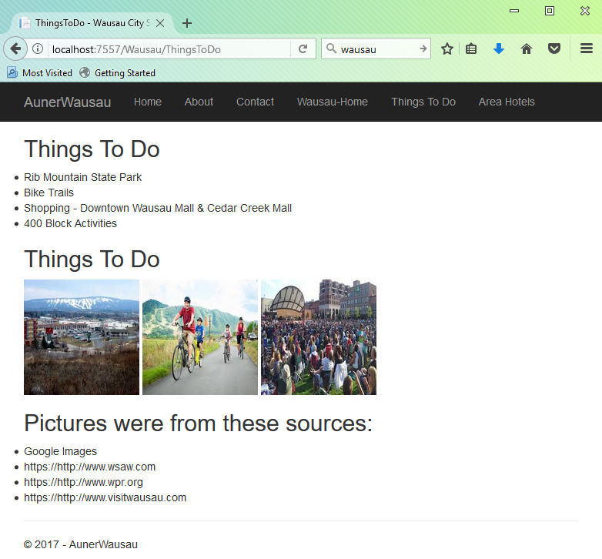 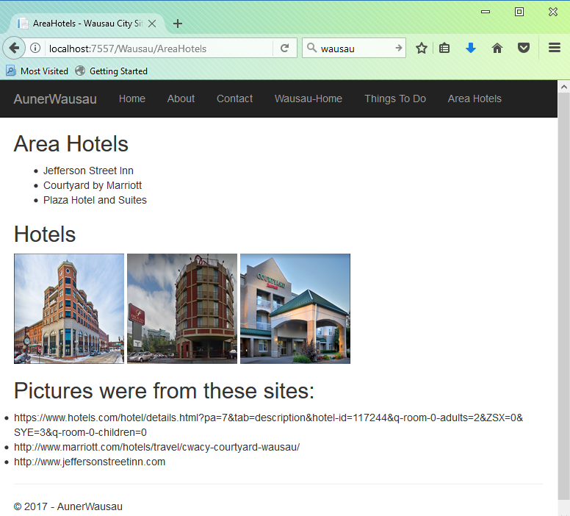

* **Save All / Test**
  + **5 points -** /Wausau/Index
  + **5 points -** /Wausau/ThingsToDo
  + **5 points -** /Wausau/Hotels
* Go back to the WausauController
  + **5 points -** Add 2 more action methods of your choice relating to Wausau (for example: schools)
    - 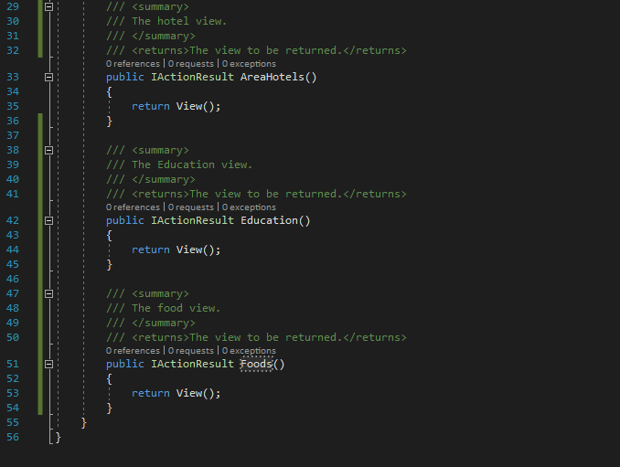Add the new corresponding Views
    - 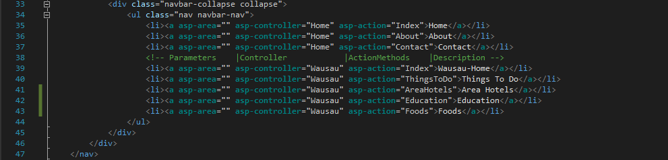Add the new corresponding links to the Shared/_Layout.cshtml file
* Modify all of your new Views corresponding to the WausauController
  + **5 points –** Display a minimum of 5 images on each of your Wausau Views. Remember to site your sources.
  + **5 points -** Add at least 5 details/bullets/items to each of your Wausau Views
  + **10 points** Modify the bootstrap.css file to change your background, heading colors, image sizes, etc.
    - All your design details (colors, sizes, fonts, etc.) should be specified in your bootstrap.css file
    - You may need to review HTML, CSS and Responsive web designs. Review in w3schools, etc. Make sure your design is neat, appealing and resizes properly when the screen size changes.
    - Proper UX design principles should be followed
* 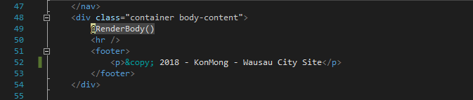**5 points -** Change the details of the HomeController / Contact.cshtml to contain your own information
* 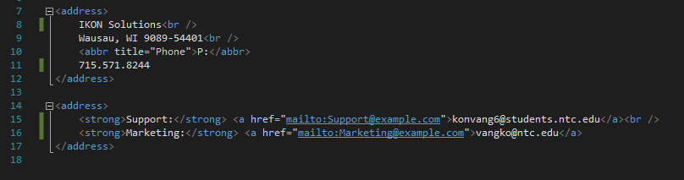**5 points -** Change the footer in _layout.cshtml – put “your name – Wausau City Site”.
* **Submit both this updated word document and both your tutorial project and your Wausau application zipped.**

**This ends Part 2 of your assignment.**